Power BI Assignment -1

Report View:

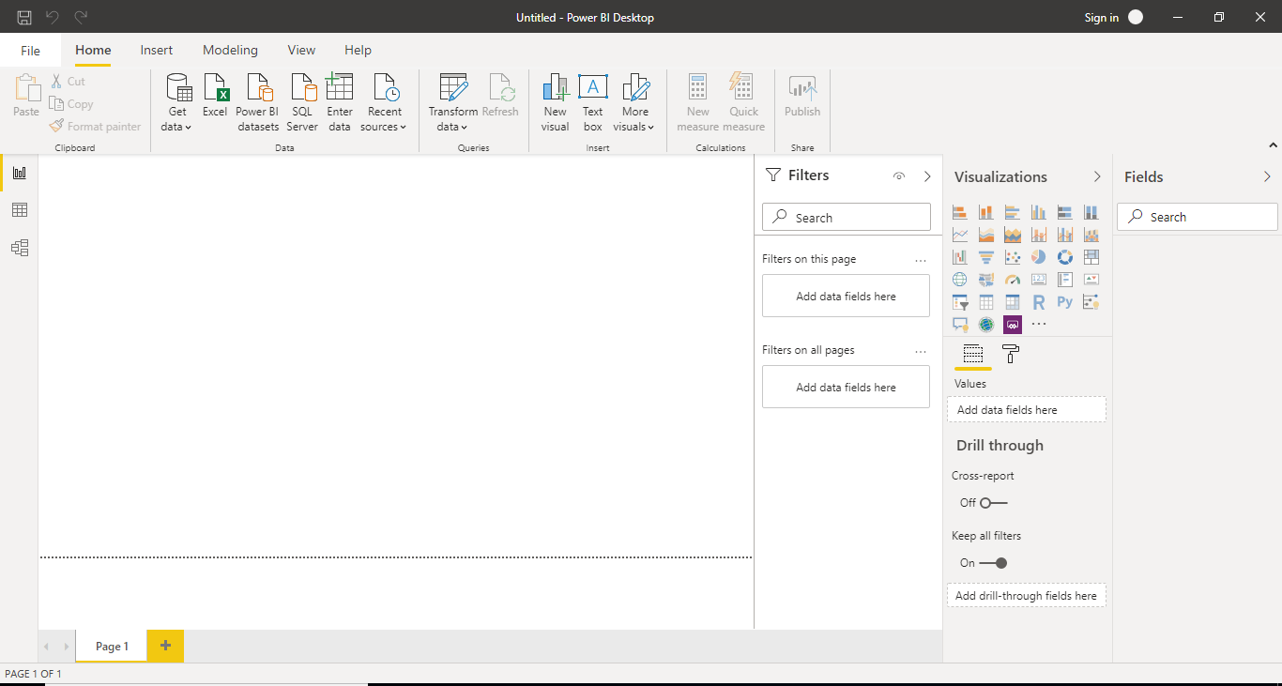

Data View:

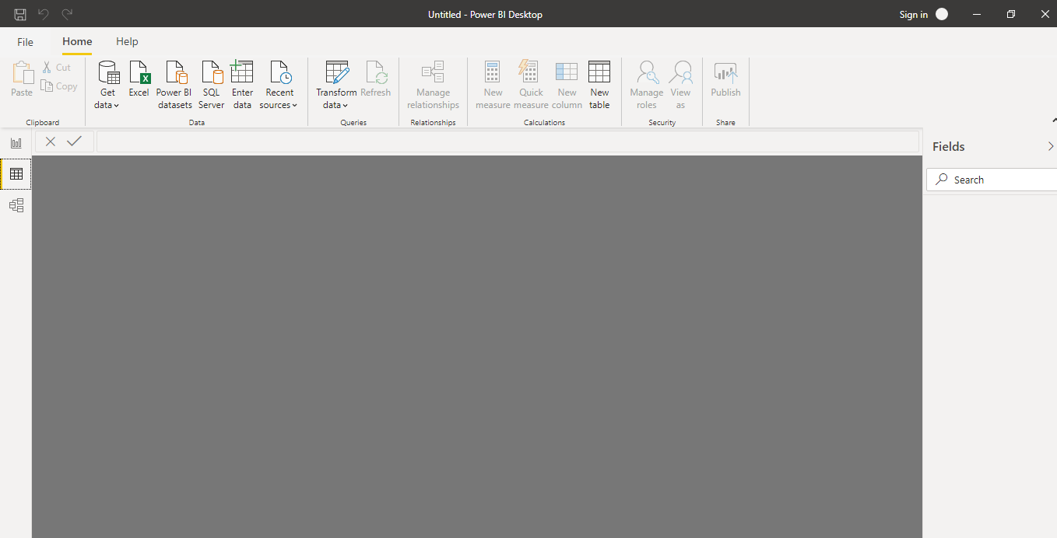

Model View:

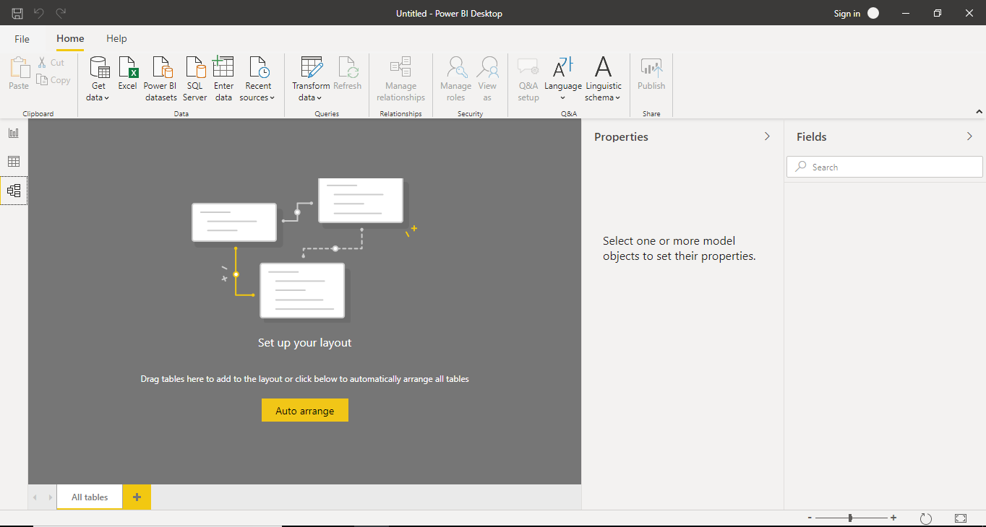

Power Query Editor:

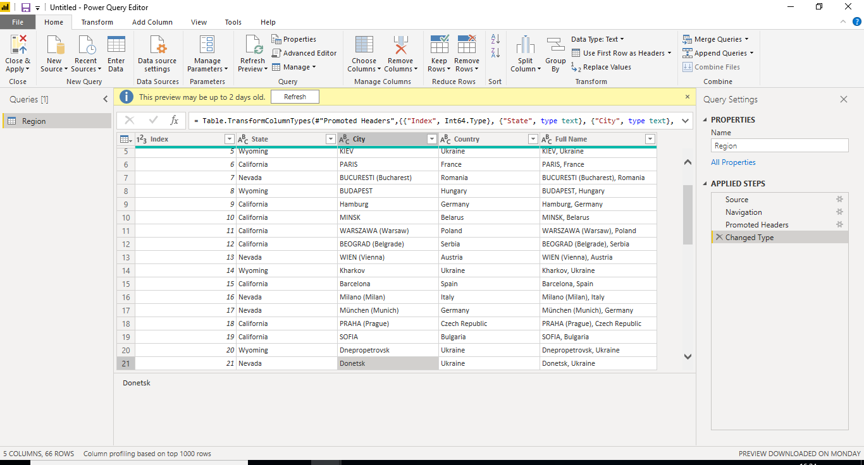

Advance Editor:

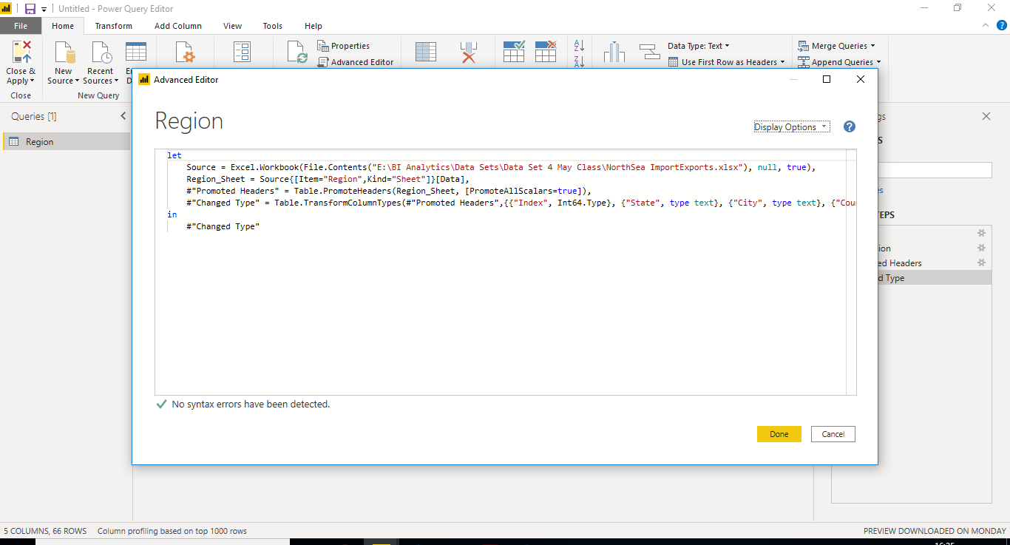

Power BI Desktop:

1. Connect to your data, wherever it is.
2. Prepare and model your data with ease
3. Open Source no need of License.

Power BI Pro:

1. Self-service and modern BI in the cloud
2. Collaboration, publishing, sharing, and ad-hoc analysis
3. Fully managed by Microsoft
4. $9.99 / Month per user.

Power BI Premium

1. Enterprise BI, big data analytics, cloud and on-premises reporting
2. Advanced administration and deployment controls
3. Dedicated cloud compute and storage resources
4. Allows any user to consume Power BI content.
5. $4,995 monthly price per dedicated cloud compute and storage resource with annual subscription